Arduino SI4635 DSP RADIO

Component Top Overlay

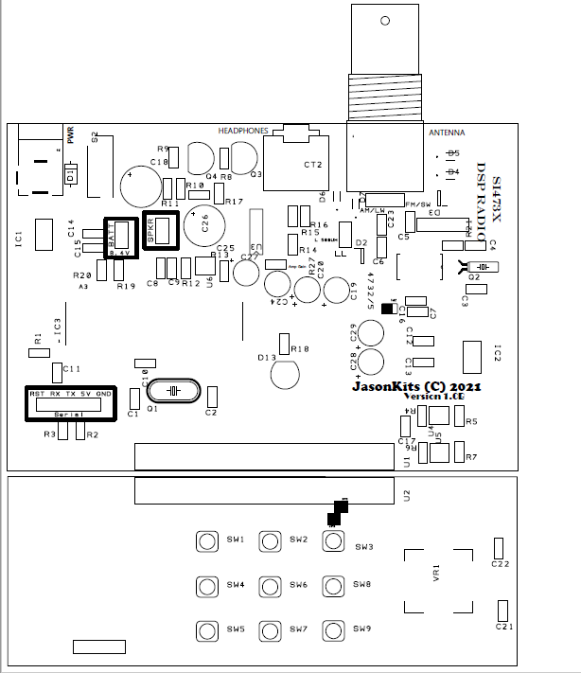

-

+

Front panel

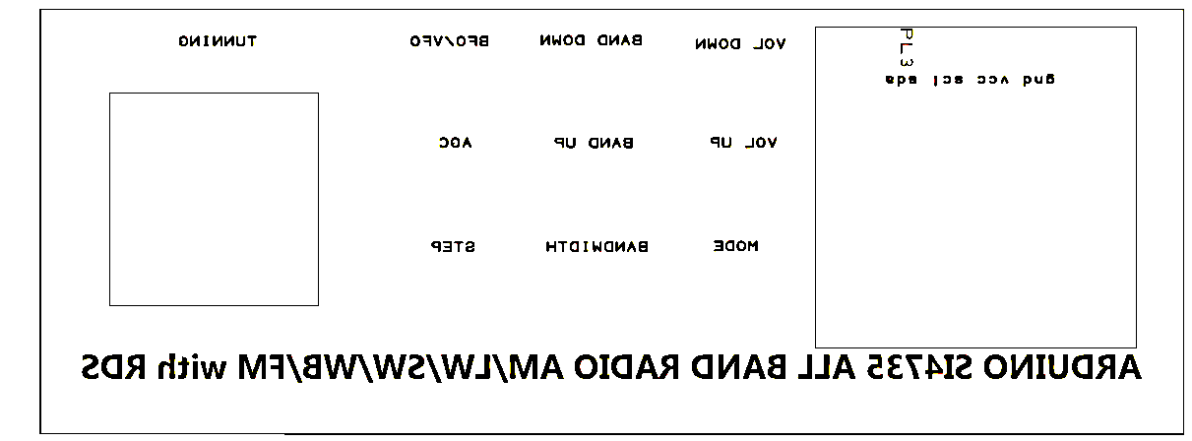

Rotary Encoder

Oled 0.96”

Schematic Diagram

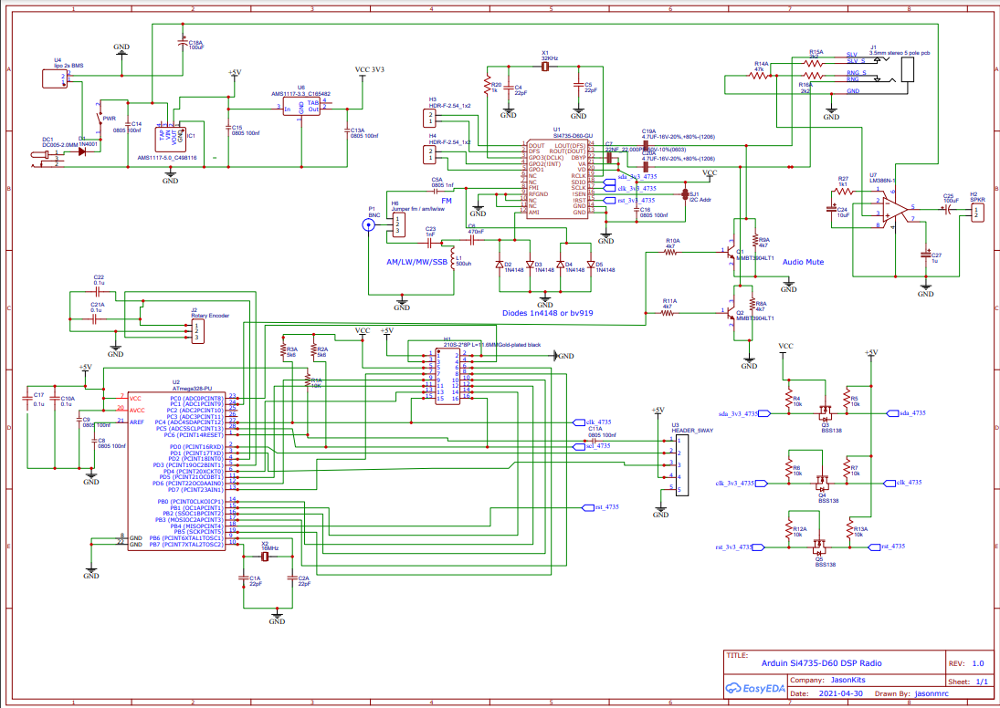

Components list

|  |  |  |
| --- | --- | --- |
|  |  |  |
| Ref Name | Qty | Component |
| Q3 | 1 | 2N3904 |
| Q4 | 1 | 2N3904 |
| PL2 | 1 | 2WP |
| PL6 | 1 | 2WP |
| LL | 1 | 2WP |
| PL5 | 1 | 3WP |
| CT2 | 1 | 3.5mm Stereo |
| PL3 | 1 | 4WP |
| PL4 | 1 | 4WP |
| PL1 | 1 | 5WP |
| U3 | 1 | 8DIL |
| U1 | 1 | 20SIL |
| U2 | 1 | 20SIL |
| IC3 | 1 | ATMEGA328P-PU |
| D2 | 1 | BAV199,215 |
| D3 | 1 | BAV199,215 |
| 1 | 1 | BNCPTH |
| U4 | 1 | BSS123 |
| U5 | 1 | BSS123 |
| U6 | 1 | BSS123 |
| C1 | 1 | C0805 – 22PF |
| C2 | 1 | C0805 – 22PF |
| C3 | 1 | C0805 – 22PF |
| C4 | 1 | C0805 – 22PF |
| C5 | 1 | C0805 – 1NF |
| C6 | 1 | C0805 – 470NF |
| C7 | 1 | C0805 – 22NF |
| C8 | 1 | C0805 – 100NF |
| C9 | 1 | C0805 – 100NF |
| C10 | 1 | C0805 – 100NF |
| C11 | 1 | C0805 – 100NF |
| C12 | 1 | C0805 – 100NF |
| C13 | 1 | C0805 – 100NF |
| C14 | 1 | C0805 – 100NF |
| C15 | 1 | C0805 – 100NF |
| C16 | 1 | C0805 – 100NF |
| C17 | 1 | C0805 – 100NF |
| C21 | 1 | C0805 – 100NF |
| C22 | 1 | C0805 – 100NF |
| C23 | 1 | C0805 – 1NF |
| C26 | 1 | C0805 – 10NF * |
| C18 | 1 | CP 1000UF 16V |
| C25 | 1 | CP 100UF 16V |
| C19 | 1 | CP1 4.7UF |
| C20 | 1 | CP1 4.7UF |
| C24 | 1 | CP1 10UF |
| C27 | 1 | CP1 10UF |
| C28 | 1 | CP1 10UF |
| C29 | 1 | CP1 10UF |
| Q1 | 1 | CRYSTALHC49UV 16MHZ |
| Q2 | 1 | CRYSTALTC26H 32.768 Khz |
| D1 | 1 | Diode 1N4001-7 |
| JP2 | 1 | JUMPER-2SMD-NC |
| JP3 | 1 | JUMPER-2SMD-NC |
| JP1 | 1 | JUMPER-3-OLD2-3 |
| S2 | 1 | LC1258EENP |
| D13 | 1 | LED |
| D4 | 1 | LL4148 – do not install if bav919 installed |
| D5 | 1 | LL4148– do not install if bav919 installed |
| D6 | 1 | LL4148– do not install if bav919 installed |
| D7 | 1 | LL4148– do not install if bav919 installed |
| VR1 | 1 | PEC11R-4220F-S0024 – rotary encoder |
| J4 | 1 | POWER_JACKPTH_LOCK |
| R1 | 1 | RESISTOR0805-RES 10K |
| R2 | 1 | RESISTOR0805-RES 5K6 *do not install |
| R3 | 1 | RESISTOR0805-RES 5K6 *do not install |
| R4 | 1 | RESISTOR0805-RES 10K * |
| R5 | 1 | RESISTOR0805-RES 10K * |
| R6 | 1 | RESISTOR0805-RES 10K * |
| R7 | 1 | RESISTOR0805-RES 10K * |
| R8 | 1 | RESISTOR0805-RES 4K7 |
| R9 | 1 | RESISTOR0805-RES 4K7 |
| R10 | 1 | RESISTOR0805-RES 4K7 |
| R11 | 1 | RESISTOR0805-RES 4K7 |
| R12 | 1 | RESISTOR0805-RES 10K |
| R13 | 1 | RESISTOR0805-RES 10K |
| R14 | 1 | RESISTOR0805-RES 47K |
| R15 | 1 | RESISTOR0805-RES 10K |
| R16 | 1 | RESISTOR0805-RES 10K |
| R17 | 1 | RESISTOR0805-RES 10R * |
| R18 | 1 | RESISTOR0805-RES 1K |
| R19 | 1 | RESISTOR0805-RES 100K |
| R20 | 1 | RESISTOR0805-RES 10K |
| R27 | 1 | RESISTOR0805-RES 1K1 |
| R21 | 1 | RESISTOR0805-RES 2.2K |
| SW1 | 1 | SW_FSM2JH tact switch |
| SW2 | 1 | SW_FSM2JH tact switch |
| SW3 | 1 | SW_FSM2JH tact switch |
| SW4 | 1 | SW_FSM2JH tact switch |
| SW6 | 1 | SW_FSM2JH tact switch |
| SW8 | 1 | SW_FSM2JH tact switch |
| SW5 | 1 | SW_FSM2JH tact switch |
| SW7 | 1 | SW_FSM2JH tact switch |
| SW9 | 1 | SW_FSM2JH tact switch |
| 4732/5 | 1 | SI4735-D60-GU OR GUR |
| IC1 | 1 | V_REG_LM1117SOT223 5V |
| IC2 | 1 | V_REG_LM1117SOT223 3V3 |
|  |  | 2 PIN JUMPER |

Note *: Omit do not install.

Connectors:

Battery: Wire the 2-pin plug, the pins are shown in the table, rear most pin is positive.

|  |
| --- |
| + Positive |
| -Negative |

Speaker: Wire a 1-Watt speaker 8 ohm to the 2 pin Plug. The pins are shown in the table. rear most pin is negative ground.

|  |
| --- |
| -Negative |
| + Positive |

Assembling the board Instructions

Front Panel

1. Start by Installing the 9 switches on the side where the function is printed – bottom side.
2. Check that all switches are installed correctly pressed down and then proceed with the installation the OLED 0.96” display.
3. Handle with care the OLED display as it is very fragile and install the rotary encoder. Insert the 4 pin connector and solder on the pcb then level the OLED and solder the 4 terminals
4. Solder the two capacitors c22, c23 on the back side of the PCB.
5. Install the 20-pin connector and solder it to main board. The connector must be connected from the bottom side of the mainboard.

Main Board

1. Start by installing the surface mount capacitors 0805
2. Install the capacitors C1,C2,C3,C4 - 22pf
3. Install the capacitors decoupling C8,C9,C10,C11,C12,C13,C14,C15,C16,C17,C21,C22 - 100nf –
4. Install the capacitors C5,C23 – 1nF
5. Install the capacitors C6 – 470nF
6. Install the capacitors C7– 22nF 0603
7. Install the resistors R8,R9,R10,R11 - 4K7
8. Install the resistors R1,R15,R16,R19 - 10K
9. Install the resistors R20 - 100K
10. Install the resistors R12, R13- 10K
11. Install the mosfets BSS138 U6
12. Install the resistors R4,R5,R6,R7,R12, R13- 10K
13. Install the mosfets BSS138 U4,U5,U6
14. Install the voltage regulators 5v and 3.3v LM1117 , Take care to install IC1 with the 5v, and IC2 3.3v.
15. Install the si4735 chip. Observe pin 1 ! solder it with a hot air soldering iron and apply flux
16. Install the two crystals Q1-16Mhz , Q2 – 32.768Khz .
17. On the radio crystal secure it with a wire loop - pads are on the top part and solder each side
18. Install the IC sockets 28 pin and 8 pin IC3, U3
19. Install the Q3, Q4 transistors, observe their pinout – emitter to ground.
20. Install the through hole capacitors C24,C27,C28,C29 – 10uF.
21. Install the through hole capacitors C19,C20 – 4.7uF.
22. Install the through hole capacitors C18 – 1000uF.
23. Install the through hole capacitors C25 – 100uF.
24. Install the protection diodes D2,D3 or else the individual diodes D4 to D7
25. Install the remaining components, switch, connectors, plugs.

Once everything is installed – connect an 8.4v power source and measure the voltage on the tab on ic1 and ic2 – you should get 5v and 3v3, respectively.

Install the 28 pin chip, the firmware is already loaded, observe pin 1 facing c11

Power on and the display will show the splash screen and defaults to FM radio mode.

Please visit Ricardo Page, where you will find a mine of resources.

Button Mapping

|  |  |  |
| --- | --- | --- |
| Show Battery State | Soft Mute in AM/LW/SW | BFO/VFO |
| Volume control | Band control AM/LW/SW/FM | AGC |
| SSB MODE LSB/USB | Bandwidth | Step |